Feature Onboarding Plan — Unified Access Management (UAR / UAM)
Oct 14, 2026 · @Shirin Mansouri

Purpose, audience and scope
This plan gives the Compass engineering, QA, product-activation and SSA teams one agreed picture of Unified Access Management: who the users are, how a request travels end to end, what data moves at each step, and how the build reaches production through four gated phases (alpha, beta, pre-prod, prod).
In scope for the first release: System Access Configuration (the integration registry), the Platform inventory of features and functions, Feature Management enhancements, the PCR schema, the unified access request form with create / update / deactivate, the request lifecycle, the SSA processing workspace, one-time credential sharing, and steward monitoring. Out of scope for the first release: automated provisioning into target systems, decommissioning the R2 steward portal and the registry spreadsheet, and new notification or system-health features beyond reading the catalogue.
Each section pairs a visual with the detail table engineering needs. Every fact comes from the handover transcript and the seven flow documents listed under Sources; proposed dates are marked as proposals.

Personas and their journeys at a glance
Five personas touch the system; only the first three operate it, and only SSA touches every target system directly.
Persona | Who they are | Screens they own | Journey outcome | Hard constraints the build must enforce
Product manager / product activation | NBIN-internal owner of the catalogue (not firm-facing) | System Access Configuration, Platform, per-system drawers, Feature Management | A feature is registered, bilingual, mapped to systems and set Active | Platform page is the only create point; Compass anchor entry is read-only; restriction resources never appear in dropdowns; English and French names required
Firm Security Steward (FSS) | Firm-side administrator enrolled in one or more firms | Users dashboard, user profile, New Request (create / update / deactivate), Requests, request detail, credentials panel | Request submitted, tracked, and credentials delivered to the end user | Sees only their firms; sees only firm-licensed modules and functions; can cancel only while Submitted; never sees which internal user is processing
SSA / ID Admin (processor) | NBIN-internal access operations | Requests queue (with Firm, Response, Resolution), intake, fulfilment, credential entry, Complete dialog | Access provisioned in every named system per the generated instructions | Start, Reject, Complete are irreversible and confirmed; Reject needs a reason; Complete needs an outcome and notes; credentials are shared only on completion
End user (advisor or assistant at the firm) | The person access is requested for | Compass sign-in, first sign-in, MFA enrolment | Account moves Invited to Active; signs into integrated systems via SSO, NetRep with its own login | One onboarding profile per Compass user; MFA and permanent password before Active
Digital support | NBIN-internal support and triage | Read-only use of catalogue, system health, firm settings | Can interpret which feature in which system is affected | No write access to the catalogue or requests

Concept model: capability to permission
A steward's selection travels seven layers from business vocabulary to a per-system instruction; the first five are catalogue, the last two are provisioning. Engineering stores the first five as typed capabilities in PCR and the last two as access rights and instructions.
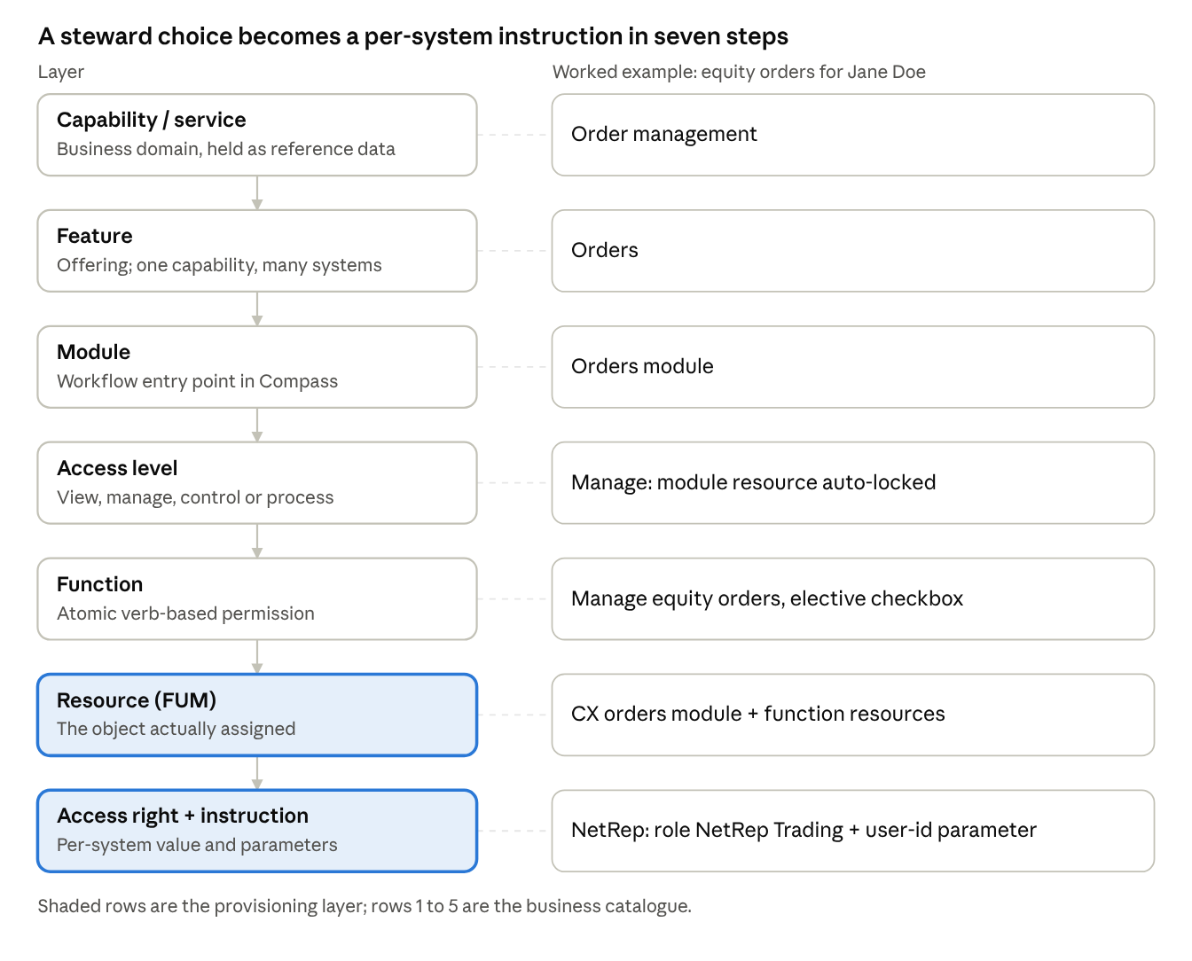
concept-to-permission ladder · 7 layers with the equity-orders example
Read top down: rows 1 to 5 are what the steward sees and selects; rows 6 and 7 are what FUM assigns and SSA provisions.
Layer | Definition | Example (red thread) | System of record | Change rate
Capability / business service | Business domain grouping related features; not assignable itself | Order management | Reference data in the content API | Low
Feature | Recognizable offering; belongs to one capability; delivered by one or more systems | Orders | Platform page in FUM (create point) | Medium
Module | Feature that delivers a whole workflow; the user-recognizable entry point and the health-reporting control point | Orders module | Feature Management (type = Module) | Low
Access level | View, Manage, Control or Process; each bundles standard assignments plus elective functions | Manage | Feature Management packaging | n/a
Function | Atomic, verb-based permission (View, Manage, Process, Control + noun) | Manage equity orders | Platform page, linked to a FUM resource | High
Resource | The FUM object actually assigned to the user; restrictions are excluded | CX orders module + function resources | FUM resource API | n/a
Access right + instruction | Generic grant (role, group, permission, entitlement, licence, code) plus the per-system steps and any required parameter | NetRep role NetRep Trading; parameter NetRep user id | Integration registry (PCR provisioning catalogue) | n/a
Two rules follow from the table: nothing can be assigned that is not a resource, and nothing can be fulfilled in an external system without an instruction row.

End-to-end user flow in four acts
One request crosses four hand-offs: the product team publishes the catalogue, the FSS submits, SSA fulfils from generated instructions, and the FSS hands credentials to the end user. The red thread used throughout: firm Harbourview Wealth, user Jane Doe, feature Orders at Manage with elective Manage equity orders, external system NetRep, request CUR-2026-0147.
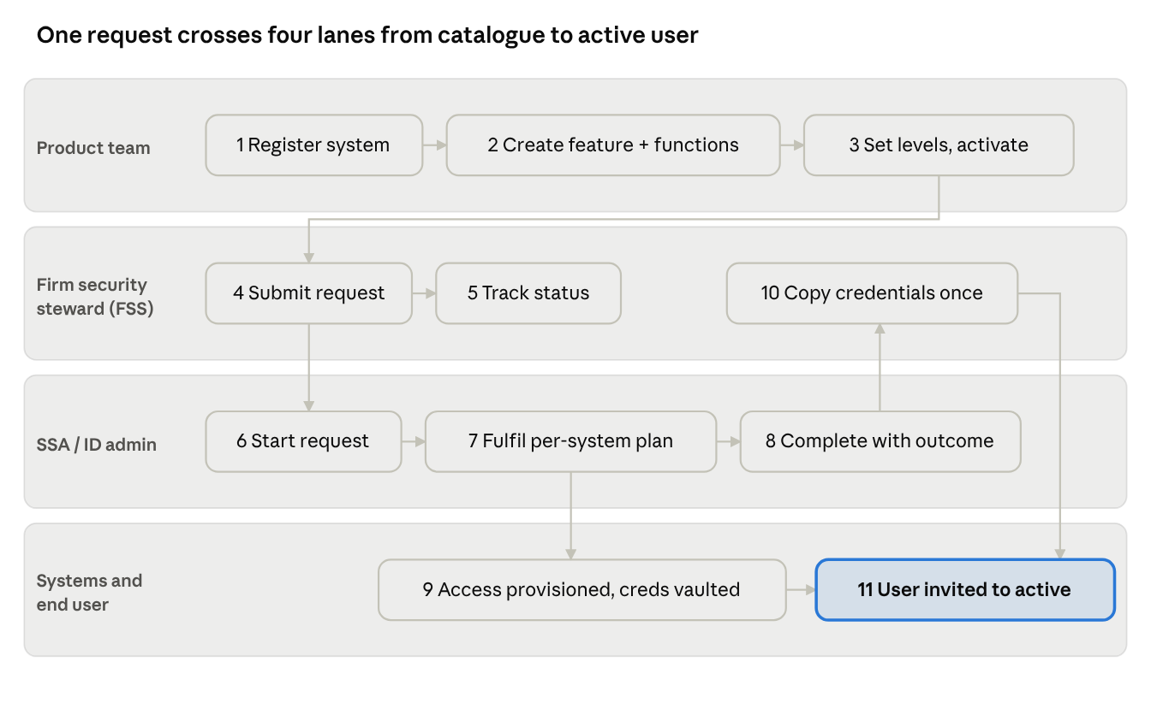
persona swimlane · 11 steps across 4 lanes
Steps 1 to 3 run once per feature; steps 4 to 11 run once per request, and the hand-off at step 10 is the only point where a secret leaves NBIN.
Step | Actor | Screen | System action | Data created or changed | Rules and validations
1 | Product manager | New Integration drawer | Register NetRep | System: name, description, auth source Sign-in, authz source External | Name unique; Compass anchor is read-only; auth enum SSO / Sign-in / Hybrid; authz enum Internal / External / Hybrid
2 | Product manager | Integrated System: NetRep | Map platform functions to assignments | Instruction rows: function, assignment type Role, value NetRep Trading | Only when authz is External; a function may map to several assignments
3 | Product manager | Platform drawer | Create feature Orders and function Manage equity orders | Capability rows (type feature / function), English + French names, linked FUM resource | Dropdown shows real resources only: restrictions filtered out; modules only for features, permission-type resources only for functions
4 | Product manager | Compass and NetRep system drawers | Associate feature and functions to the systems that deliver them | System to capability links | Pick by reference only; no creation on system pages
5 | Product manager | Feature Management | Set type Module, capability Order management, levels, dependencies, status Active | Feature config: per-level standard assignments (module resource auto-locked) plus elective functions | Status path Unconfigured, Planned, Pre-release, Active, Deprecated; feature list sorts by English label (French for French users)
6 | FSS | New Request, Create | Enter Jane Doe identity | Requested user: email, first and last name, language | Email typeahead scoped to firm; duplicate in firm raises a warning; language defaults to the steward's
7 | FSS | New Request, Client and account access | Grant data scope | Firm-level flag or RR / IA code list | Firm-level disables code selection; pasted codes parsed, de-duplicated, invalid ones rejected and shown
8 | FSS | New Request, Feature access | Pick Orders at Manage, tick Manage equity orders | Feature selections; required parameter values (firm, NetRep user id) | Rendered from reference data filtered by firm resources: unlicensed modules removed, their functions removed, unassigned functions removed, empty capabilities hidden, core capabilities first, fixed display order
9 | FSS | New Request footer | Submit | Request CUR-2026-0147: Submitting then Submitted; notification to SSA queue | Required parameters must be present before submit; firm settings that hide a module hide it here too
10 | FSS (optional) | View request, Submitted | Cancel | Request to Cancelled (terminal); last-modified name and time | Cancel visible only with Manage User Requests and only while Submitted; a failed cancel leaves status unchanged
11 | SSA | Intake | Start Request or Reject | Under review with start date in history and requestor notified; or Rejected (terminal) with reason stored | Both confirmed; reason required on reject; concurrent action by another admin yields an error toast and a refresh
12 | System | Provisioning plan | Compare current with requested assignments per system | Instruction list with parameter values from the request | No existing functions in a system: External auth creates user and shares credentials; Hybrid with firm IDP creates user, links account, shares nothing; no remaining functions: deactivate in that system
13 | SSA | Fulfilment | Provision in Compass and NetRep; enter Compass user id and temporary password | Secret: request, system, vault reference; credential state Pending entry, Scheduled, Shared | Credentials visible only to authorised internal admins; Replace allowed before completion
14 | SSA | Complete dialog | Complete | Request to Complete (terminal); outcome status and notes in history; credentials released; requestor notified | Outcome enum Completed successfully / Completed with exceptions / Unable to complete; notes required
15 | FSS | View request, Complete | Read confirmations, copy credentials once | Audit record (actor, user record, event, outcome, timestamp); password deleted; account linked to profile | Seven ordered steps: validate, decrypt server-side, build labelled text, clipboard write, delete, associate account, refresh; never logged or retrievable again
16 | End user | Compass sign-in | First sign-in | User state Invited to First sign-in to Active | Terms, permanent password, mobile MFA, security preferences before Active

Data sequence diagrams per flow
Four exchanges carry the journey; each sub-section pairs the sequence with the payload and persisted entity of every call. All PCR and PAM tables are new, in a separate schema on the same database server as FUM.

5.1 Product configuration (FUM to PCR)
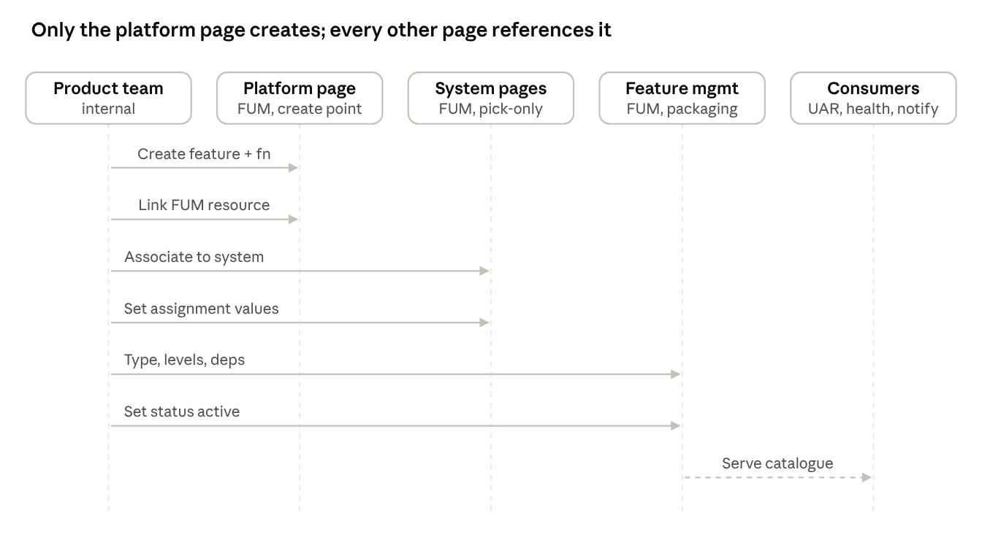
product configuration sequence · 7 calls across 5 participants
Solid arrows are writes by the product team; the dashed arrow is a read-only serve to the three consumers.
Call | From, to | Payload | Persisted entity | Notes
Create system | Product team, Integration registry | name, description, authSource, authzSource, integrationType | System | Compass anchor entry is system-defined
Map function assignment | Product team, Integration registry | functionId, assignmentType (Role, Group, Permission, Entitlement, Licence, Custom), assignmentValue | Instruction | One function may yield several rows
Create feature or function | Product team, Platform page | nameEn, nameFr, type (feature or function), resourceId | Capability (+ resource reference) | Resource dropdown filtered from the FUM resource API
Associate to system | Product team, System page | systemId, capabilityId | System-capability link | Pick-only; shows where a feature is used
Configure feature | Product team, Feature Management | featureType, capabilityGroup, systemIds, levels with standard and elective sets, dependencies, status | Feature configuration | Module resource auto-added and locked per level
Serve catalogue | Feature Management, UAR / health / notifications | read-only query by feature id | none | Consumers reference the stable feature definition

5.2 Request submission (PAM with PCR)
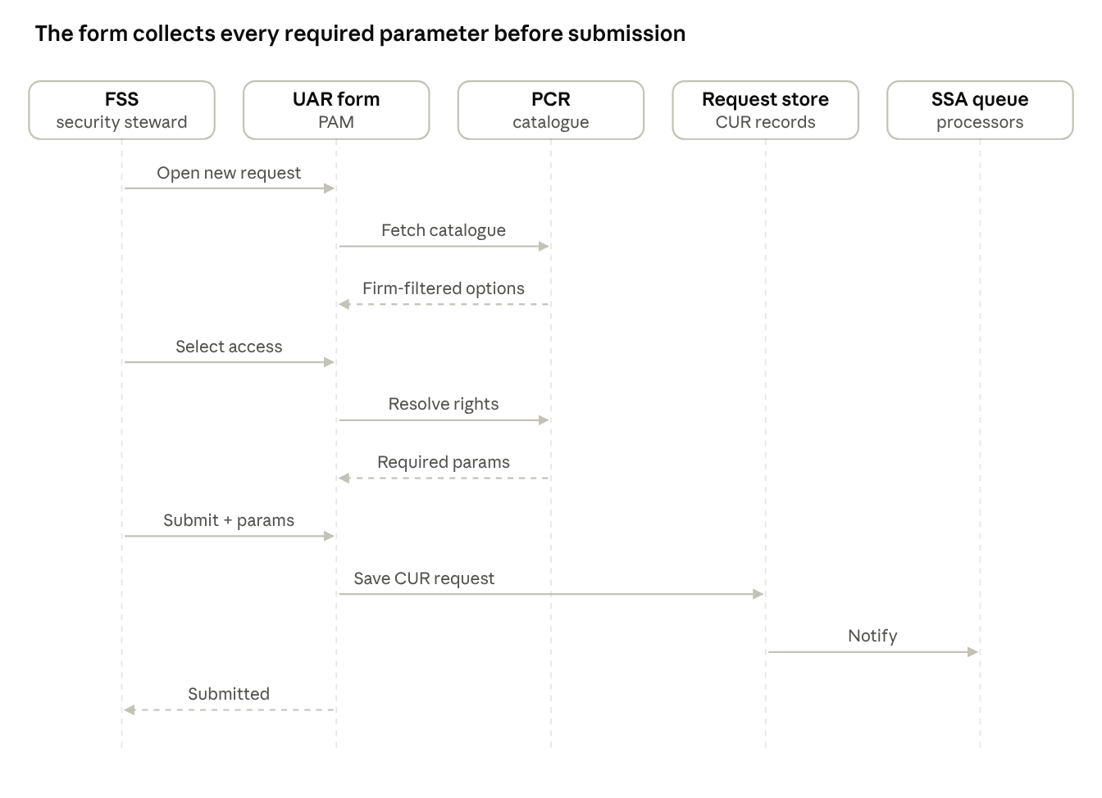
request submission sequence · 10 calls across 5 participants
PCR is called twice: once to filter what the firm may see, once to resolve which instructions need a parameter the steward must supply before submit.
Call | From, to | Payload | Persisted entity | Notes
Open form | FSS, PAM | request type, firm context | none | Type toggle Create / Update / Deactivate
Fetch catalogue | PAM, PCR | firm id, firm resource set | none | Capability reference data filtered before render
Resolve rights | PAM, PCR | selected capabilities and levels | none | Returns access rights, instructions, required parameters
Submit | PAM, Request store | requestedUser, dataAccess, featureSelections, parameterValues | Request (Submitting then Submitted), Requested user | CUR prefix id assigned
Notify | Request store, SSA queue | request id, firm | Request history | Steward sees Submitted and may cancel

5.3 Processing and fulfilment (SSA)
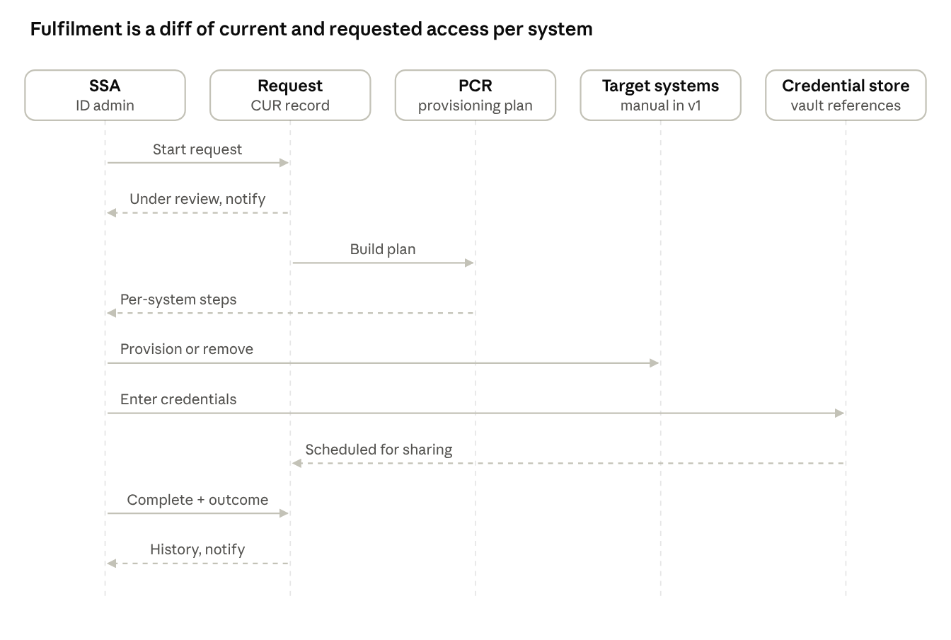
processing and fulfilment sequence · 9 calls across 5 participants
The target-system calls are manual in v1: SSA executes the generated steps and records the result; only the credential entry and the completion write back to the platform.
Call | From, to | Payload | Persisted entity | Notes
Start or reject | SSA, Request | action, rejection reason when rejecting | Request status, history, start date | Confirmed; notifies requestor
Build plan | Request, PCR | current assignments per system, requested assignments | Provisioning plan | Diff drives add, change, remove per system
Provision | SSA, target systems | per-system instruction with parameter values | Target-system state (manual in v1) | Compass via resources; others via assignment values
Enter credentials | SSA, Credential store | userId, temporaryPassword (encrypted) | Secret (request, system, vault reference) | States Pending entry, Scheduled, Shared; Replace allowed
Complete | SSA, Request | outcomeStatus, completionNotes | Request Complete, history | Releases credentials and notifies requestor

5.4 Close-out and activation (FSS and end user)
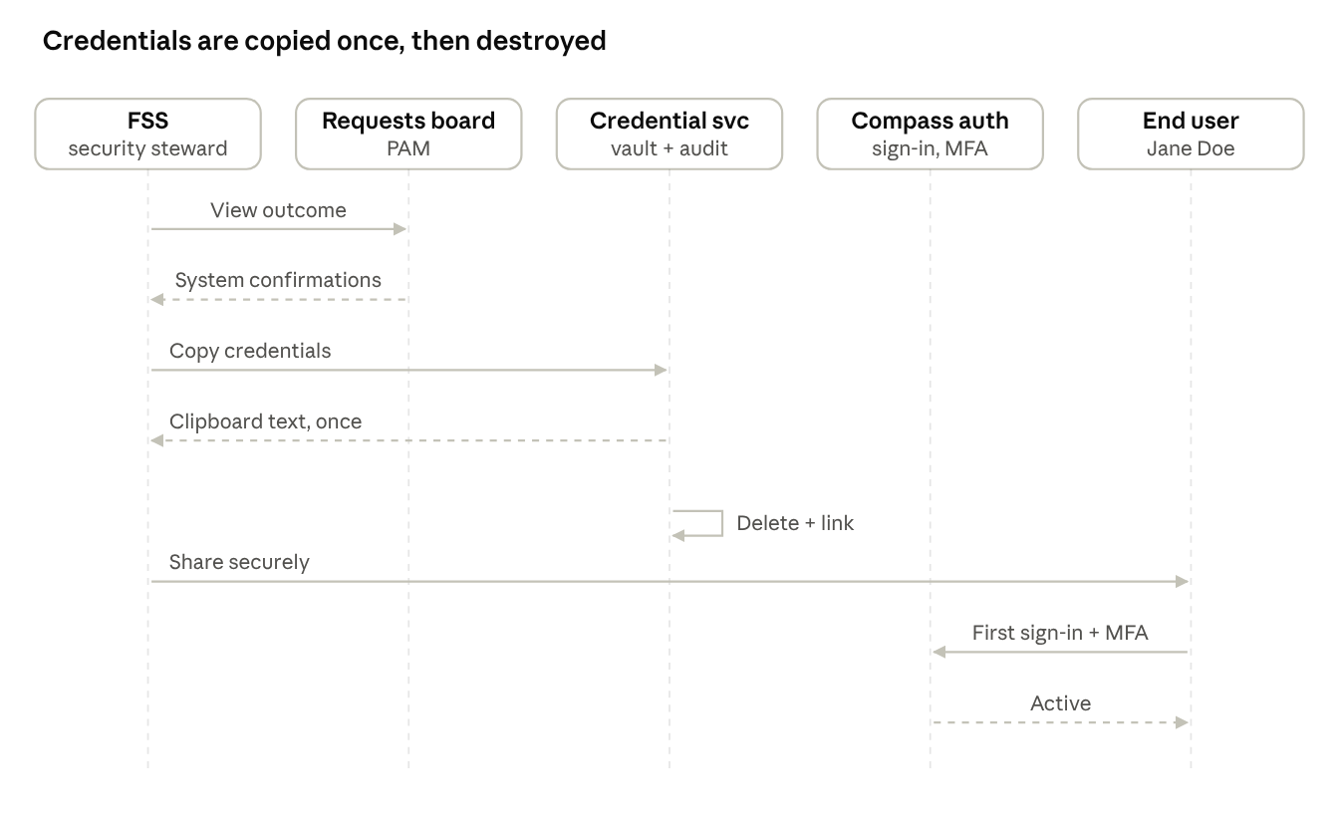
close-out and activation sequence · 8 calls, one self-loop
The self-loop on the credential service is the only destructive step: the password is deleted and the account linked before the steward's screen refreshes.
Call | From, to | Payload | Persisted entity | Notes
View outcome | FSS, Requests board | request id | none | Per-system confirmations driven by instruction completion
Copy credentials | FSS, Credential service | request id, confirmation | Audit event (non-sensitive), account link | Validate, decrypt server-side, clipboard, delete, link, refresh
Share credentials | FSS, end user | out of band, approved secure method | none | Platform never exposes the password again
First sign-in | End user, Compass auth | temporary credentials, MFA enrolment, permanent password | User state Invited to Active | NetRep keeps its own login created in 5.3

Data model and state machines
PCR keeps one typed capability table instead of separate module, feature and function tables, and one generic access right instead of system-specific permission shapes; everything below is new. Feature status is a straight run (Unconfigured, Planned, Pre-release, Active, Deprecated); the request and user lifecycles branch, so they are drawn.
Entity | Key fields | Relationships | Build notes
Request | id (CUR prefix), type, status, submitted by and at, last modified, history | one Requested user; many selected services; many parameter values; many Secrets | Status transitions guarded server-side; history is append-only
Requested user | identity fields, language, existing user reference or null | belongs to Request | Distinct from the FUM user table; may not exist yet
Service | name (customer-facing), display order, core flag, localized name and description | many Capabilities | Reference data; drives capability order on the form
Capability | name (En, Fr), type (module, feature, function), resource reference, status | belongs to a Service; many Access rights; delivered by many Systems | Replaces mixed resource rows in FUM for catalogue purposes
Access right | name, kind (role, group, permission, entitlement, licence, code) | belongs to a Capability; many Instructions | Deliberately generic across R2, Secure Zone, NetRep
Instruction | system, steps, required parameter (optional), assignment value | belongs to an Access right and a System | Parameters are collected on the form before submit
System | identifier, name, authSource, authzSource, integrationType | many Instructions; many Capabilities | Compass anchor read-only
Secret | request, system, vault reference | belongs to Request | Holds only the reference; the vault holds the value
Provisioning plan | request, per-system add / change / remove lists | derived from Request + PCR | Generated on submit or start; regenerated on change
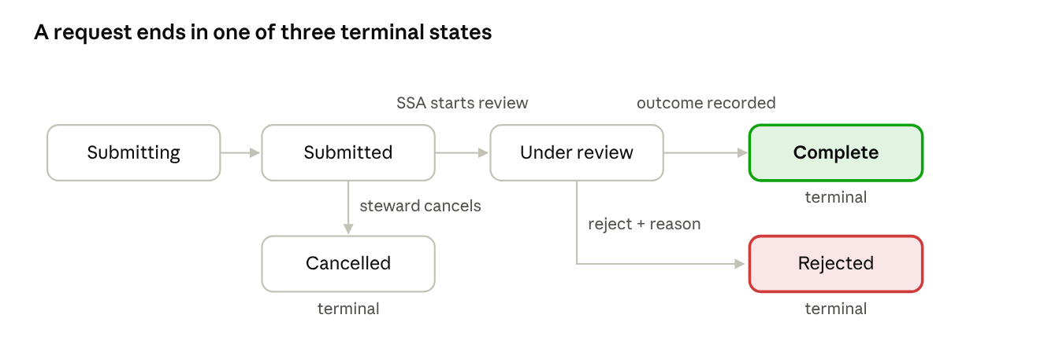
request lifecycle · 6 states, 3 terminal
A steward can cancel only while Submitted; Start, Reject and Complete are confirmed and irreversible, and history records every transition with actor and time.
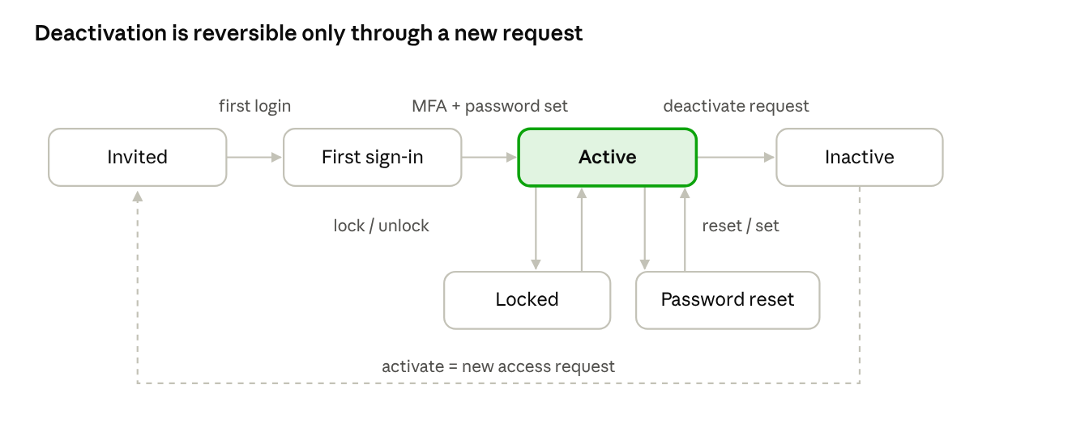
user lifecycle · invited to active, recoverable lock and reset
Locked and Password reset recover back to Active; Inactive removes access across all offerings, and reactivation is a brand-new access request, never an in-place toggle.

System integration matrix
Only Compass is authorised internally; every other system is reached through an instruction, and only NetRep and true external apps need a separate login.
System | Auth source | Authz source | Instruction carries | Credentials created? | On deactivation | Attestation hook
Compass (CX), anchor | Hybrid: SSO for external-IDP firms, platform sign-in otherwise | Internal (FUM resources via firm and user packages) | Resource assignments | Compass user id + temporary password unless the firm uses its own IDP | Deactivate in Compass | Source of truth
Compass Legacy (R2) | SSO | External | R2 assignment values per function | No | Remove values in R2 per instruction | Instruction vs actual reconciliation
Secure Zone | SSO (after the project; no credentials) | External | Function group codes | No | Remove function groups | Instruction vs actual reconciliation
NetRep | Sign-in | External | Role | Yes: login created, secret vaulted; NetRep user id captured as a request parameter | Deactivate the NetRep login | User id matched against the attestation file
External apps (Harmony, Evercore, Croesus) | External app | External | Licence only | Per app | Revoke licence | None

Screen-by-screen build specification
Fifteen screens, grouped by source document; each row is the acceptance baseline engineering builds and QA tests against.
Source document | Screen | Key components | Rules and validations
Manage integration | Systems Access Configuration list | Table of systems: name, type, auth, authz, feature and function counts, last modified user and time | Compass and Platform entries read-only
Manage integration | New Integration drawer (XXL, right) | Name, description, integration type, auth source, authz source, Features and Functions reference pickers, assignment type and value rows | Assignment rows only when authz is External; a function may map to several rows
Manage integration | Platform drawer | Capability selector; feature and function rows with English and French names and a FUM resource dropdown | Only create point; dropdown excludes restrictions; features pick module-type resources, functions pick permission-type resources
Manage integration | Integrated System drawer (Compass, Legacy, Secure Zone, NetRep) | Picked features and functions; per-row assignment values; auth and authz summary | Pick-only; values are content supplied by the product team
Manage Features | Features registry list | Name, capability, status pill, type, system, V / M / C / P chips, dependencies, modified by | Sorted by localized label; new Platform entries appear automatically as Unconfigured
Manage Features | Feature config drawer | Type (Module, Assigned feature, Integrated app, External app, General feature), capability, system list, per-level standard and elective assignments, dependency picker, status | Module resource auto-added and locked per level; Assigned and General features have no level configuration
Manage Firm Users | Users dashboard | Search, filter, sort; columns User ID (multi-account tooltip), Name, Email, Status, password and security-question dots, actions menu; Export Users; New Request; 50 per page | Actions gated by status: Active gets Update, Reset password, Reset MFA, Deactivate; Inactive gets Activate only; no Compass account gets Update only
Manage Firm Users | User profile modal | User information, Accounts (system ids, reset actions), Data access (codes with copy), Feature access (level per module, electives) | Read-only; changes go through a request
Manage Requests | New Request drawer: Create / Update / Deactivate | Type toggle; identity (typeahead, names, language); Client and account access (firm-level checkbox or RR / IA multi-select with paste and copy); Feature access accordions | Typeahead scoped to firm; duplicate warning on create, no-user error on update; update blocked for deactivated users (use a new request); firm filtering and capability ordering rules
Manage Requests / Monitor requests | Requests list (steward) | Request ID (CUR), status, type, user, submitted, last updated; search, sort, filters; paging | Firm-level segregation; stewards see only enrolled firms
Monitor requests | View request (steward) | Read-only summary left; Request panel right (type, status, activity); Cancel Request | Cancel only while Submitted and with Manage User Requests; processor identity hidden; completed view shows credentials and per-system confirmations
Process Request | Requests queue (processor) | Adds Firm, Response time, Resolution time, Last modified user | Firm visible to parent-firm or multi-firm users with Process User Requests
Process Request | Intake | Start Request and Reject with confirm dialogs | Irreversible; reject reason required; failure cases produce an error toast and refresh
Process Request | Fulfilment and Complete | Per-system instructions; Compass credentials component (Pending entry, Scheduled, Shared) with Replace; Complete dialog | Outcome status and completion notes required
Monitor requests | Copy credentials | Confirmation dialog; labelled clipboard text; success toast without secrets | Entry conditions checked; decrypt only server-side; delete only after clipboard success; account association idempotent

Prioritization of capabilities
P0 is the minimum that lets one request travel end to end; everything that only improves speed, visibility or reconciliation waits for a later phase.
Priority | Capability | Why it sits here | Target phase
P0 | Manage integration: system registry with auth and authz sources, assignment mapping | Everything else references it; confirmed first in the build order | Alpha
P0 | Platform inventory: create features and functions with English and French names and resource links | Single create point; feeds the UAR, health and notifications | Alpha
P0 | Feature Management enhancements: type, capability, levels, standard and elective bundling, dependencies, status | Turns the inventory into assignable packages | Alpha
P0 | PCR schema: service, capability, access right, instruction, parameter, system, request, requested user, secret | New tables in a separate schema; nothing exists today | Alpha
P0 | PAM form: create, update, deactivate with firm filtering and required-parameter collection | The steward-facing replacement for three legacy channels | Beta
P0 | Request lifecycle: submitting, submitted, cancelled, under review, rejected, complete with history | Governs every downstream action | Beta
P0 | Processing workspace: queue, intake, fulfilment, complete with outcome | Without it nothing is fulfilled | Beta
P0 | Credential handling: entry states, release on completion, copy-once with deletion | Security control on the most sensitive data in the flow | Beta
P1 | Provisioning plan generation: current vs requested diff per system with instruction list | Removes the mental diff SSA does today; manual execution stays | Beta
P1 | Steward monitoring: SLA-oriented columns, status change surfacing | Visibility for firms; measures human throughput in v1 | Beta
P1 | Bilingual labels on the request form sourced from the catalogue | Avoids a dev request per label change | Pre-prod
P1 | User profile modal and Export Users | Oversight features; not on the critical path | Pre-prod
P2 | Attestation reconciliation using the NetRep user-id parameter | Needs real request volume to validate | Prod, first wave
P2 | System health and notifications reading the enhanced catalogue | Health already integrated; notifications in progress | Prod, first wave
P2 | Information-required status, if adopted | Depends on the open lifecycle decision | After decision
P3 | Automated provisioning into target systems | Replaces manual instruction execution | Post-prod
P3 | Decommission the R2 steward portal and the registry spreadsheet | Only once the catalogue is trusted as master | Post-prod

Phased deployment plan: alpha, beta, pre-prod, prod
Four gated phases move UAM from lower environments to production, with go-live proposed for Feb 23, 2027; the November 15 target discussed in the handover maps to the alpha exit (catalogue complete), not to production. Windows are proposals as of October 14, 2026 and need confirmation with release management, including any year-end change freeze.
Phase | Proposed start | Environment and users | Scope delivered | Entry criteria | Exit gate
Alpha | Oct 27, 2026 (about 4 weeks) | Dev / QA; product team and FUM engineering only | Manage integration, Platform inventory, Feature Management enhancements, PCR schema; one-time spreadsheet load of the registry | Integration registry API available; PCR schema created; resource API filter for restrictions in place | G1: catalogue complete for Compass, R2, Secure Zone, NetRep and external apps; review finds zero misregistrations; UAR form renders from the catalogue in the lower environment
Beta | Nov 23, 2026 (about 8 weeks, allowing for a year-end freeze) | UAT; one or two pilot firms with friendly stewards; SSA processors | PAM create / update / deactivate, request lifecycle, processing workspace, provisioning plan, credential handling, steward monitoring | G1 passed; pilot firms enrolled and firm settings loaded; SSA trained on instructions and credential flow | G2: pilot requests of all three types processed end to end, including one NetRep credential hand-off; cancel and reject paths exercised; no credential exposure in logs
Pre-prod | Jan 18, 2027 (about 4 weeks) | Pre-prod mirror of production; all firms' data; digital support | Full data load and firm-settings parity, bilingual labels, user profile and export, attestation dry run, runbooks | G2 passed; production data load plan approved; security review scheduled | G3: security sign-off on the credential flow and firm segregation; operations sign-off on runbooks and rollback rehearsal; digital support trained on system health and catalogue interpretation
Prod | Feb 23, 2027 go-live | Production; firms onboarded in waves | Everything above; attestation reconciliation and notifications in the first wave; R2 steward portal moved to read-only once all firms are live | G3 passed; go / no-go held; first-wave firms and rollback owner named | G4: first-wave requests completed without manual workaround; monitoring and SLA reporting live; decision taken on R2 and spreadsheet decommission date
↗ deployment roadmap · 4 phases, gates G1 to G4, go-live Feb 23
Each diamond is the exit gate defined in the table above; the beta band is the longest because it absorbs the year-end change freeze, and every date shifts together if that freeze grows.

Non-functional, security and audit requirements
The credential flow and firm segregation carry the security review; everything else is auditability and predictable behaviour under concurrency.
Area | Requirement | Source rule
Credential confidentiality | Temporary passwords stay encrypted until the steward confirms a copy; decryption happens only server-side for that one operation; the value is never written to logs, analytics, browser storage, page markup or request history | Monitor requests, copy credentials
Credential lifecycle | Deletion is atomic or idempotent, happens only after the clipboard write succeeds, and the value is never retrievable again; the account is then associated with the profile exactly once | Monitor requests, processing steps 1 to 7
Credential visibility | Credentials are visible only to authorised internal administrators and are never exposed on the request record after sharing; release to the firm happens only when the request is Complete | Process Request, sharing credentials
Firm segregation | Stewards see only requests and users for firms they are enrolled in; the firm filter runs before the capability tree renders; the processor's identity is hidden from firms | Manage Requests, Monitor requests, Process Request
Irreversibility | Start, Reject, Complete and Cancel require confirmation; a race with another administrator returns an error toast, leaves the state unchanged and refreshes the view | Process Request, Monitor requests
Auditability | Request history records every status change with actor and timestamp, the rejection reason, the outcome status and notes; catalogue records keep last-modified user and time; the copy event stores only non-sensitive fields | Process Request, Manage integration, Monitor requests
Bilingual content | English and French names for features and functions live in the catalogue and drive the request form, system health messages and notifications without a code change | Manage integration, Manage Features
Validation at entry | Resource dropdowns exclude restrictions and wrong resource types; pasted RR / IA codes are parsed, de-duplicated and invalid ones surfaced; required parameters block submit | Handover, Manage Requests
Performance and paging | Lists page at 50 rows; the capability tree is filtered server-side by firm resources before render | Manage Firm Users, Manage Requests
Data placement | PCR and PAM tables live in a separate schema on the existing FUM database server; the secret table holds vault references only | Handover (data model walkthrough)

Risks, open items and decisions needed
Five of the ten items are decisions the build cannot absorb on its own; all are cheaper before the engineering estimate locks than after.
Item | Type | Owner (role) | Needed by
Information-required status appears in the monitoring flow but not in the request lifecycle; adopt it or remove it | Decision | Product (UAM) with SSA | Beta start
One published glossary: business service vs capability vs module, and PCR's typed capability | Decision | Product activation | Alpha exit
Deactivated vs Inactive wording unified across the user flows | Decision | Product (UAM) with UX | Alpha exit
Registry ownership: product activation owns the catalogue, but where activation sits organisationally is unresolved | Decision | Platform leadership | Alpha exit
Catalogue data promotion from lower environments to production: test then promote, or load directly | Open question | FUM engineering with release management | Pre-prod start
Resource clean-up: feature-flag resources that should not be assignable | Risk | FUM engineering | Alpha
Manual fulfilment in v1 means SLA response and resolution measure human throughput | Risk | SSA | Beta
Attestation reconciliation for NetRep depends on the user-id parameter captured at request time | Risk | SSA with security | Pre-prod
November 15 target vs the phased plan: confirm which milestone the date refers to | Decision | Platform leadership | Now
Year-end change freeze and its effect on the beta window | Open question | Release management | Beta start

Ownership, RACI and sources
Product activation is accountable for the catalogue, FUM engineering for the platform, SSA for fulfilment; roles are named rather than people because activation's organisational home is still being decided.
Workstream | Responsible | Accountable | Consulted | Informed
Catalogue content: systems, features, functions, levels, bilingual names | Product activation | Product activation lead | Product managers of each feature, FUM product | Digital support, SSA
Platform build: integration registry, Platform page, Feature Management, PCR, PAM | FUM engineering | FUM product manager | UX, data architecture, security | Product activation, SSA
Request processing and instructions | SSA / ID Admin | SSA lead | FUM product, security | Firms via request status
Firm enablement: steward training, pilot selection, waves | Product activation | Product activation lead | Digital support, relationship managers | Firms
Security review of credential flow and firm segregation | Security | Security lead | FUM engineering, SSA | Platform leadership
Release gates G1 to G4 and environments | Release management | Platform leadership | FUM engineering, SSA, security | All
Sources: handover transcript (platform uplift walkthrough and PCR data model); New version of definitions; Manage integration user flow; Manage Features user flow; Manage Requests user flow; Manage Firm Users user flow; Monitor requests user flow; Process Request user flow; Onboarding Profiles (Confluence export). Companion files: UAM / UAR visual specification pack (PDF) and the design prompt pack.

Glossary
Term | Meaning in this plan
UAM | Unified Access Management: the whole capability, catalogue plus request plus fulfilment
UAR | Unified Access Request: the steward-facing request form and lifecycle (also called PAM in the data model)
PAM | Platform access management: JP's name for the request-side tables (request, requested user, parameters, secrets)
PCR | Platform Capability Registry: the catalogue database (service, capability, access right, instruction, system)
FUM | Feature and User Management: the internal Compass platform-management application that hosts the catalogue screens
FSS | Firm Security Steward: the firm-side administrator who submits and monitors requests
SSA / ID Admin | The internal access-operations team that processes and fulfils requests
CX | Compass X, the native Compass platform (anchor system)
R2 | Compass Legacy, authorised externally via its own assignment values
CUR | Prefix of Compass User Request ids
Access level | View, Manage, Control or Process on a module
Standard vs elective | Assignments included automatically with a level vs optional functions the steward ticks
Restriction | A deny-type FUM resource that must never be linked to a feature
Instruction | Per-system steps and assignment value that fulfil an access right, with an optional required parameter

